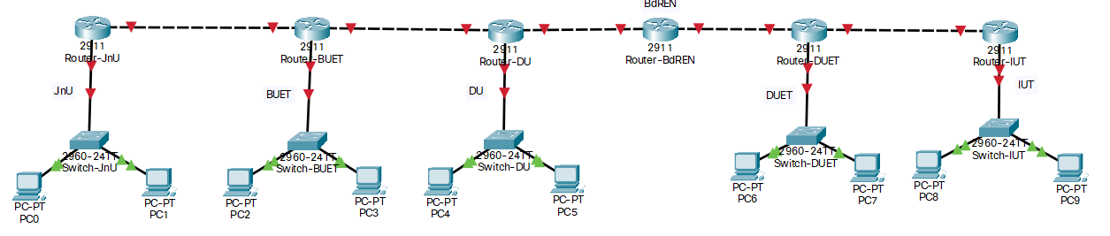

Bangladesh has taken a Block of IP address from APNIC starting with **1XY.XY.0.0/20**. The authority wants to create ten (10) subnets to distribute the addresses in different academic institutions.

Design the subnetworks and give the slash notation for each subnetwork.

Implement the network topology in packet tracer and test data transmission among different networks using **Static routing** only.

**N. B.: Site Address: 1XY.XY.0.0/20 [XY represents last two digits of your student ID]**